Oracle JOINS are used to retrieve data from multiple tables. An Oracle JOIN is performed whenever two or more tables are joined in a SQL statement.

There are 4 different types of Oracle joins:

* Oracle INNER JOIN (or sometimes called simple join)
* Oracle LEFT OUTER JOIN (or sometimes called LEFT JOIN)
* Oracle RIGHT OUTER JOIN (or sometimes called RIGHT JOIN)
* Oracle FULL OUTER JOIN (or sometimes called FULL JOIN)

So let's discuss Oracle JOIN syntax, look at visual illustrations of Oracle JOINS, and explore Oracle JOIN examples.

**INNER JOIN (simple join)**

Syntax

The syntax for the INNER JOIN in Oracle/PLSQL is:

SELECT columns

FROM table1

INNER JOIN table2

ON table1.column = table2.column;

Visual Illustration

In this visual diagram, the Oracle INNER JOIN returns the shaded area:

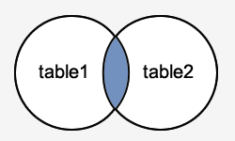

The Oracle INNER JOIN would return the records where *table1* and *table2* intersect.

**LEFT OUTER JOIN**

Another type of join is called an Oracle LEFT OUTER JOIN. This type of join returns all rows from the LEFT-hand table specified in the ON condition and **only** those rows from the other table where the joined fields are equal (join condition is met).

Syntax

The syntax for the Oracle **LEFT OUTER JOIN** is:

SELECT columns

FROM table1

LEFT [OUTER] JOIN table2

ON table1.column = table2.column;

In some databases, the LEFT OUTER JOIN keywords are replaced with LEFT JOIN.

Visual Illustration

In this visual diagram, the Oracle LEFT OUTER JOIN returns the shaded area:

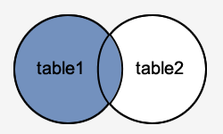

The Oracle LEFT OUTER JOIN would return the all records from *table1* and only those records from *table2* that intersect with *table1*.

**RIGHT OUTER JOIN**

Another type of join is called an Oracle RIGHT OUTER JOIN. This type of join returns all rows from the RIGHT-hand table specified in the ON condition and **only** those rows from the other table where the joined fields are equal (join condition is met).

Syntax

The syntax for the Oracle **RIGHT OUTER JOIN** is:

SELECT columns

FROM table1

RIGHT [OUTER] JOIN table2

ON table1.column = table2.column;

In some databases, the RIGHT OUTER JOIN keywords are replaced with RIGHT JOIN.

Visual Illustration

In this visual diagram, the Oracle RIGHT OUTER JOIN returns the shaded area:

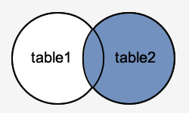

The Oracle RIGHT OUTER JOIN would return the all records from *table2* and only those records from *table1* that intersect with *table2*.

**FULL OUTER JOIN**

Another type of join is called an Oracle FULL OUTER JOIN. This type of join returns all rows from the LEFT-hand table and RIGHT-hand table with nulls in place where the join condition is not met.

Syntax

The syntax for the Oracle **FULL OUTER JOIN** is:

SELECT columns

FROM table1

FULL [OUTER] JOIN table2

ON table1.column = table2.column;

In some databases, the FULL OUTER JOIN keywords are replaced with FULL JOIN.

Visual Illustration

In this visual diagram, the Oracle FULL OUTER JOIN returns the shaded area:

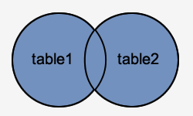

The Oracle FULL OUTER JOIN would return the all records from both *table1* and *table2*.